Composition (IEW) 2020-2021
Westfield Washington Public Library
(with distance-learning backup)

Introductory Composition / Grades 2-4 / Thursdays 10:30-11:30am / 24 weeks
Elementary Composition / Grades 4-6 / Tuesdays 10:30-11:30am / 24 weeks
Intermediate Composition / Grades 6-8+ / Wednesdays 10:30-11:30am / 30 weeks
Advanced Composition / Grades 8-10+ / Mondays 10:30am-12pm / 30 weeks
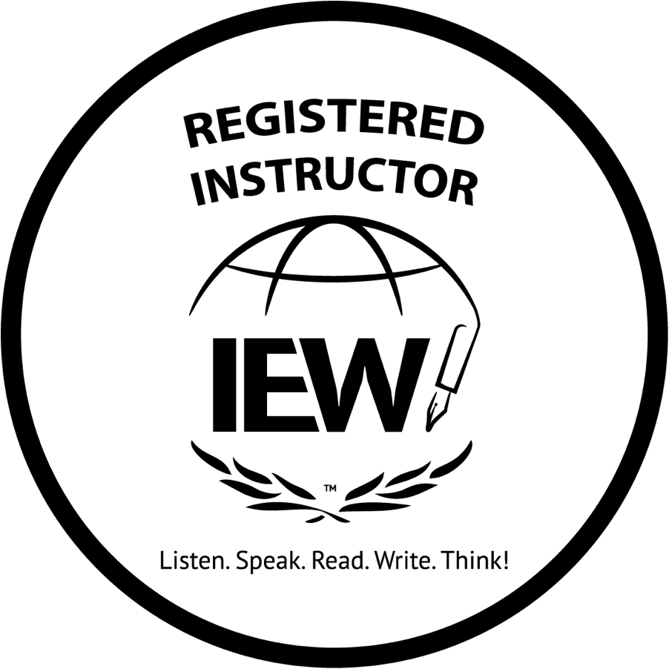

Mrs. Daryl Kessler 317-201-5477 (voicemail / text)
REDBRICK LANGUAGE ARTS dkessler@redbricklanguagearts.com

School-year classes / 6-week sessions
Introductory, Elementary, and Intermediate IEW calendar
- Session 1: Week of September 7 – week of October 12
- Session 2: Week of October 19 – week of November 30 (minus Thanksgiving week)
- Session 3: Week of January 4 – week of February 8
- Session 4: Week of February 15 – week of April 5 (minus weeks of 3/8 and 3/15 for spring break)
- Session 5 (Intermediate IEW): Week of April 12 – week of May 17
Advanced IEW calendar (differs slightly due to Monday holidays)
- Fall: 9/14-10/26 (minus Labor Day, Columbus Day); 11/2-12/7 (including Thanksgiving week)
- Spring: 1/4 – 2/15 (minus MLK Day); 2/22 – 4/12 (minus 3/8 and 3/15); 4/19 – 5/24

ALL IEW COMPOSITION CLASSES:
    - All courses are prepared with distance-learning backup via Zoom.
    - Yearlong classes; no mid-year enrollment
    - Minimum 4 students; maximum 8 students (waiting list maintained if needed)
    - Register online through WWPL children’s department.
    - Enrollment in any session is not complete until paid in full. (See individual class descriptions for class fees.) You may pay this instructor directly by check or via PayPal or Venmo. Direct any payment questions to instructor.
- One-time non-refundable $15 supplies/services fee due upon initial enrollment ($5 discount for enrollment and first payment by 8/24)
    - Each session payment is due 1 week before the session begins. Payments made after first day of class (any session) are subject to a $10 late fee per week.
    - Curriculum purchases are to be made separately. See individual class descriptions for info regarding additional required purchases.

Class summary. These writing classes are founded on the concepts taught in the Institute for Excellence in Writing (IEW) program by Andrew Pudewa. The IEW program teaches structure and style: structure to develop organizational skills, and style to allow for individuality and creativity. The high-interest source materials for these classes have been chosen to launch the imagination and enthusiasm of elementary, middle school, and high school students. Grade-appropriate source materials are provided.

In the intro and elementary classes, writing during the class period is typically limited to crafting keyword outlines, brainstorming applicable descriptive details, and working through periodic worksheets to support new stylistic or structural elements. Intermediate students can expect to do more in-class writing toward the end of the year, and advanced students will write during class more frequently. Occasionally, all students have the opportunity to read aloud from their compositions. The last week of each semester is usually reserved for an engaging and constructive review activity.

Science Unhinged!
This year, the intro, elementary, and intermediate classes will be writing on some unusual and fascinating topics drawn from the formal, natural, applied, and social sciences. We’ll also craft some of our own versions of familiar stories. The advanced class will explore a similar but wider range of subject-matter.

Although these writing classes may use literature as a springboard for various lessons and will regularly address practical grammar and usage, none is designed to function as or replace a literature or grammar course.

Note that there is a bit of overlap in the targeted grade span of each class. If you have a 4th grader or 6th grader, for example, you can enroll him down or up depending on experience or confidence level. Please ask if you need assistance determining the most appropriate class for your child, especially with regard to the advanced class.

Introductory IEW/Grammar (grades 2-4) Thursdays 10:30-11:30am — 60-minute class; 24 weeks
- This is an ungraded class.
- $72 per 6-week session (additional $15 supply fee added first session)
- Typed papers are preferred but not required; handwriting should be legible.

The introductory IEW class for grades 2-4 features the following:
- Most of the weekly writing assignments are limited to one short paragraph; you may expect 1-2 hours of homework each week.
- Students engage in abundant group in-class preparation for individual written work — outlining, brainstorming stylistic elements and material for topic sentences, and so on.
- As far as structural elements, we cover IEW units 1-5, and touch on units 6 and 7.
- Of the IEW stylistic elements, we will address all the basic dress-ups and just one sentence opener. We may explore a variety of decorations (including dialog and similes, for example).
- We’ll delve into narrative, report, and essay writing. Most assignments will be of 1 paragraph. Students will work up to some finished compositions of 3 paragraphs.
- Students will learn some basics of MLA formatting.

This introductory IEW class is best suited for students in 2nd-4th grade who
- Can read aloud and to themselves with or without assistance
- May have limited experience with grammatical concepts, but are acquainted with nouns, verbs, and adjectives
- Can usually recognize a complete sentence as beginning with a capital letter and ending with punctuation, with or without parental help
- Can copy notes from the whiteboard

Elementary IEW Composition (grades 4-6) Tuesdays 10:30-11:30am — 60-minute class; 24 weeks
- This is an ungraded class.
- $72 per 6-week session (additional $15 supply fee added first session)
- Typing and midweek submissions via MS Word or Google Docs are required.
- Student email address is recommended for timely receipt of corrections from teacher.
- Concurrent enrollment in Junior Analytical Grammar class is recommended.

The elementary IEW class for grades 4-6 features the following:
- Most of our weekly writing assignments are limited to 1 or 2 paragraphs; you may expect 2-3 hours of homework each week.
- Students engage in abundant group in-class preparation for individual written work — outlining, brainstorming stylistic elements and material for introductions and conclusions, and so on.
- As far as structural elements, we’ll cover IEW Units 1-7, and parts of Unit 8.
- Of the IEW stylistic elements, we will address all the basic dress-ups and most of the sentence openers. In addition, we’ll look at an assortment of decorations (including literary devices).
- We’ll delve into narrative, report, and essay writing. Most assignments will be of 1 paragraph. Students will work up to some finished compositions of 3-4 paragraphs.
- Students will learn the basics of MLA formatting.

This elementary IEW class is best suited for students in 4th-6th grade who
- Can read aloud and to themselves
- May have limited experience with some grammatical concepts, but can usually identify the basic
8 parts of speech
- Can recognize and form complete sentences, understand the rules of subject-verb agreement, and maintain consistency in verb tense, with or without parental help
- Can copy notes from the whiteboard and take notes as instructed

Intermediate IEW Composition (grades 6-8+) Wednesdays 10:30-11:30am — 60-minute class; 30 weeks
- This is an ungraded class.
- $78 per 6-week session (additional $15 supply fee added first session)
- Typing and midweek submissions via MS Word or Google Docs are required.
- Student email address is recommended for timely receipt of corrections from teacher.
- Required: Student Resource Packet ($15 PDF or $19 printed; available at www.iew.com/shop/products/student-resource-packet; copies may be made for immediate family members). Please obtain packet (and, if PDF, print in its entirety) before the first day of class.
(Note that this is not the same as the Student Resource Notebook.)
- Concurrent enrollment in Analytical Grammar class is recommended.

The intermediate IEW class for grades 6-8 features the following:
- Most of our weekly writing assignments are limited to one to three paragraphs; you may expect 3-4 hours of homework each week.
- Students engage in abundant group in-class preparation for individual written work — outlining, brainstorming stylistic elements and material for introductions and conclusions, and so on.
- As far as structural elements, we cover most of IEW Units 1-8.
- Of the IEW stylistic elements, we will address all the basic dress-ups and sentence openers. In addition, we’ll look at some advanced styles and an assortment of decorations (including literary devices).
- We’ll delve into narrative, report, and essay writing. Most assignments will be of 1-3 paragraphs. Students will work up to several 5-paragraph compositions, and one independent project.
- Students will learn the basics of MLA formatting and citation.

This intermediate IEW class is best suited for students in 6th-8th or higher grade who
- Can easily identify the basic 8 parts of speech
- Can easily recognize and form complete sentences, understand the rules of sentence agreement, and maintain consistency in verb tense
- Can hand-write as needed for notetaking and drafting during class

Advanced IEW Composition (grades 8-10+) Mondays 10:30am-12pm — 90-minute class; 30 weeks
- This is a graded class and counts as 1 credit toward high school graduation requirements.
- $117 per 6-week session (additional $15 supply fee added first session)
- Typing and midweek submissions via MS Word or Google Docs are required.
- Student email address is recommended for timely receipt of corrections from teacher.
- Access to laptop (or similar) is recommended for use during class as needed.
- Required: Student Resource Packet ($15 PDF or $19 printed; available at www.iew.com/shop/products/student-resource-packet; copies may be made for immediate family members). Please obtain packet (and, if PDF, print in its entirety) before the first day of class.
(Note that this is not the same as the Student Resource Notebook.)
- Concurrent or previous enrollment in an Analytical Grammar class is strongly advised.

The advanced IEW class for grades 8-10+ features the following:
- Most of our weekly writing assignments range from one to three paragraphs; you may expect 3-5 hours of homework each week.
- Students engage in abundant group in-class preparation for individual written work — such as group and individual outlining, brainstorming stylistic elements and material for intros and conclusions.
- As far as structural elements, we cover IEW Units 1-8.

- Of the IEW stylistic elements, we will address all the basic dress-ups and sentence openers. In addition, we’ll explore a number of advanced styles decorations (including literary devices).
- We’ll delve into narrative, report, and essay writing. Students will construct several 5-paragraph compositions, perhaps one longer “super essay” composition, and one independent project.
- Students will learn and be held accountable for following the basics of MLA formatting and citation.

This advanced IEW class is best suited for students in 8th-10th grade or higher who
- Can easily identify the basic 8 parts of speech
- Can confidently recognize and form complete sentences of varying structure, understand the rules of sentence agreement, and maintain consistency in verb tense
- Can hand-write relatively quickly for notetaking and drafting during class

REQUIREMENTS FOR EVERY STUDENT
- 2-inch three-ring binder reserved solely for use with this writing class
- 5 tabbed dividers, labeled in order as follows: Sources & outlines, Drafts & checklists, Revisions, Worksheets, Reference
- Packet of handouts provided at the beginning of each session
- Zippered pouch for pencils, highlighters, tickets, etc.
- Sharpened pencils and 2 colors of highlighting markers
- 8.5x11-inch, hole-punched filler paper for use in class
- White copy or printer paper (for printing compositions)
- Access at home to age-appropriate dictionary and thesaurus, or online versions of same
- Access at home to a computer and printer (for typing and printing assignments)
Additional requirements for elementary, intermediate, and advanced IEW students
- Typing ability, or access to a typist who is willing to provide the service
- Access to MS Word or Google Docs for midweek assignment submission
- Access to email for midweek communications

Additional requirements for intermediate and advanced IEW students ONLY
- IEW’s Student Resource Packet ($15 PDF, $19 printed; available at www.iew.com/shop/products/student-resource-packet; copies may be made for immediate family members). Please obtain packet (and print in its entirety if PDF) before the first day of class.
- Library card

Students (or parents) must have email and Internet access for the following purposes:
- Students will write by hand during class but will submit homework via Google Docs or
MS Word email attachments.
- Follow-up information (lesson recap and assignment details) will be posted each week on Google Classroom or sent via email.
- Midweek support will be offered via Zoom.
- In the event of a weather or widespread health emergency, unforeseen library closings, or teacher illness, classes will be held online (during the usual class hour or rescheduled as necessary) via Zoom.
- In the event of student absences, with forewarning I may be able to video-record specific lessons. Any recordings will be accessible via Google Classroom.
- I will provide detailed instructions for each of the above as needed.

Teacher information. Mrs. Daryl Kessler has a background in English and publishing,
and now enjoys helping students express themselves in writing with clarity and individuality.
For the past twelve years she has taught a variety of homeschool language arts classes, including composition, creative writing, and grammar. She has had the pleasure of offering classes through WWPL since 2014.

