POETIC LICENSE
Creative Writing Fall 2020
Westfield Washington Public Library
(with distance-learning backup)
Grades 4-8 / Thursdays 11:30am-12:30pm / 12 weeks (Fall)

Mrs. Daryl Kessler 317-201-5477 (vm / text)
REDBRICK LANGUAGE ARTS dkessler@redbricklangarts.com

Fall-semester class / two 6-week sessions
- Session 1: September 10 – October 15
- Session 2: October 22 – December 3 (minus Thanksgiving week)

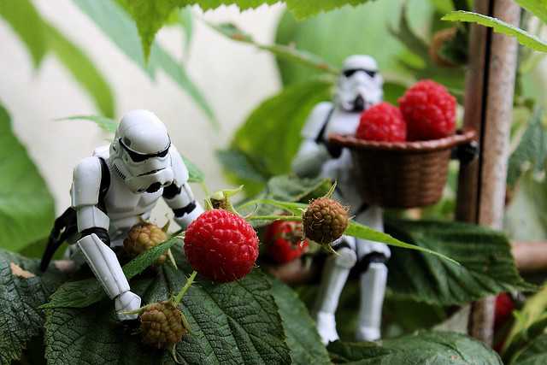
Get your
creative juices
flowing! Sweet Harvest
A tiny storm trooper named Gary
Wished to harvest a single raspberry.
Though his neighbor friend Wade
Gamely sprang to his aid,
Still a trio was all they could carry.

DocChewbacca 2009

Thursdays 11:30am-12:30pm (grades 4-8) — 60-minute class; 12 weeks
    - Course prepared with distance-learning backup via Zoom
    - Minimum 4 students; maximum 8 students (waiting list maintained if needed)
- No prerequisites; mid-session enrollment accepted
- $72 per 6-week session
- One-time non-refundable $15 materials fee due upon enrollment ($5 discount for enrollment and first payment by 8/24). No curriculum to purchase.
    - Register online through WWPL children’s department.
    - Enrollment in any session is not complete until paid in full. You may pay this instructor directly by check or via PayPal or Venmo. Direct any payment questions to instructor.
    - Each session payment is due 1 week before the session begins. Payments made after first day of class (any session) are subject to a $10 late fee per week.

Attention, students actively seeking a creative outlet! Bring your pencils, paper, and imagination, and we’ll explore creative expression through the written word.

POETRY. During this 12-week session poetry is in the spotlight. In addition to rhyme and meter and many poetic forms, we will also study figures of speech and poetic devices. Past projects have included song parodies and advertising jingles, Shakespearean sonnets based on fairy tales, and haiku art projects. We will give some attention to the recitation of humorous and classic poems. One goal will be to produce a class literary magazine at the end of the semester.

Choice of content. This class will not feature lengthy or heavy-duty assignments; rather, it will focus on experimenting with varied methods of poetic expression, and students will be free to choose their own subject-matter. Although the concepts learned will build from one lesson to the next, most weeks will consist of stand-alone assignments. Teacher feedback will concentrate more on encouragement rather than correction. Weekly homework will vary but should average about 1 hour per week. No grades will be issued.

Cooperative and independent opportunities. Frequently, classwork will involve group effort on a joint enterprise, yet students will have ample opportunity to produce individual work at home. At the end of the semester, students will enjoy popcorn and earn prizes while competing in a team-based review game.

Please note: Although we will occasionally borrow IEW methods, this class is not intended to replace a formal IEW (Institute for Excellence in Writing) or IEW-based composition class.

NOTE: Reluctant or stubborn writers likely will not find this class a good fit. We will move at a quick clip in class, exploring lots of fun but potentially unfamiliar poetry styles. Students will explore styles in which they excel, and ones they prefer — as well as a few they find irksome, no doubt — by earnestly attempting and practicing each as we tackle it. Students are encouraged to share their work. Effort, enthusiasm, and participation are vital to student success in and enjoyment of the class.

REQUIREMENTS FOR EVERY STUDENT
- 1-inch three-ring binder with 2 dividers (“Handouts” and “My Work”)
- A zippered pouch for pencils, tickets, etc.
- Packet of handouts provided at the beginning of each session
- Sharpened pencils and 8.5x11-inch, hole-punched filler paper
- Access at home to age-appropriate dictionary and thesaurus, or online versions of same
- Access to Internet and email

Students (or parents) must have email and Internet access for the following purposes:
- Students will write by hand during class but will submit homework via Google Docs or MS Word email attachments.
- Follow-up information (lesson recap and assignment details) will be posted each week on Google Classroom or sent via email.
- In the event of a weather or widespread health emergency, unforeseen library closings, or teacher illness, classes will be held online (during the usual class hour or rescheduled as necessary) via Zoom.
- In the event of student absences, with forewarning I may be able to video-record specific lessons. Any recordings will be accessible via Google Classroom.
- I will provide detailed instructions for each of the above as needed.

Mrs. Daryl Kessler has a background in English and publishing, and she enjoys helping students
express themselves in writing with clarity and individuality. Over the past twelve years, she has taught
a variety of homeschool language arts classes, including creative writing, IEW composition, and grammar.
She has had the pleasure of offering classes through WWPL since 2014.

